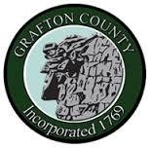
GRAFTON COUNTY ALTERNATIVE SENTENCING
Intimate Partner Domestic Violence Program
3801 Dartmouth College Highway North Haverhill, New Hampshire 03774
Phone (603) 787-2042 Fax (603) 787-2044

GRAFTON COUNTY EMERGE REFERRAL FORM
Intimate Partner Domestic Violence Program

Referral Information Date of Referral:

Name: Phone #: _____________________

Address/Department:

E-mail:

Offender information

Name: _____________________________ DOB: ____________________________

Phone #: ___________________________ Address: __________________________

Email: _____________________________ __________________________

Please Check Below:

Court Ordered

Self-referral

Behavior based

PLEASE ATTACH ORDER AND DISCOVERY

Email to Nicole Mitchell, AS@graftoncountynh.gov

